**6. Present the high-level architectural configuration of the software according to the chosen style/pattern. Ensure the proposed architecture is consistent with the UML diagrams provided in steps 1 and 2.**

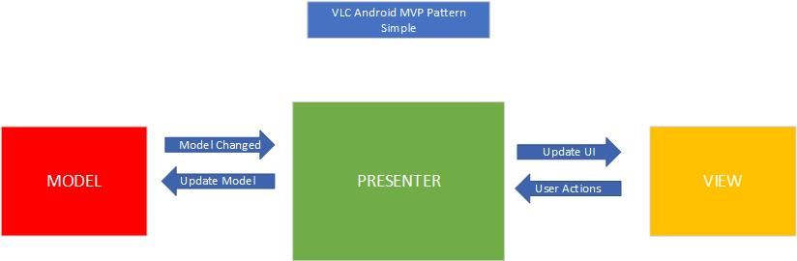

The chosen model was MVP (Model View Presenter), which is not specific to android but does work well and is the chosen more common method for app development on android.

The Presenter is the one that connects all the other components together. The view interacts with the presenter by calling its functions. The presenter is the main chunk of this software as the view is provided by Androids API UI.

The model consists of two parts. There is a local small database and Androids SQLite service.

MVP in android is mainly used for making UI’s such as VLC android. It also makes unit testing easier.

.

The Presenter is in between Model and the View. And, it triggers the business logic, and lets to know ‘the View’ when to update.

It recovers data received from the Model and shows it in the View.

It interacts with the Model, then fetches and transforms the data from the Model to update the view.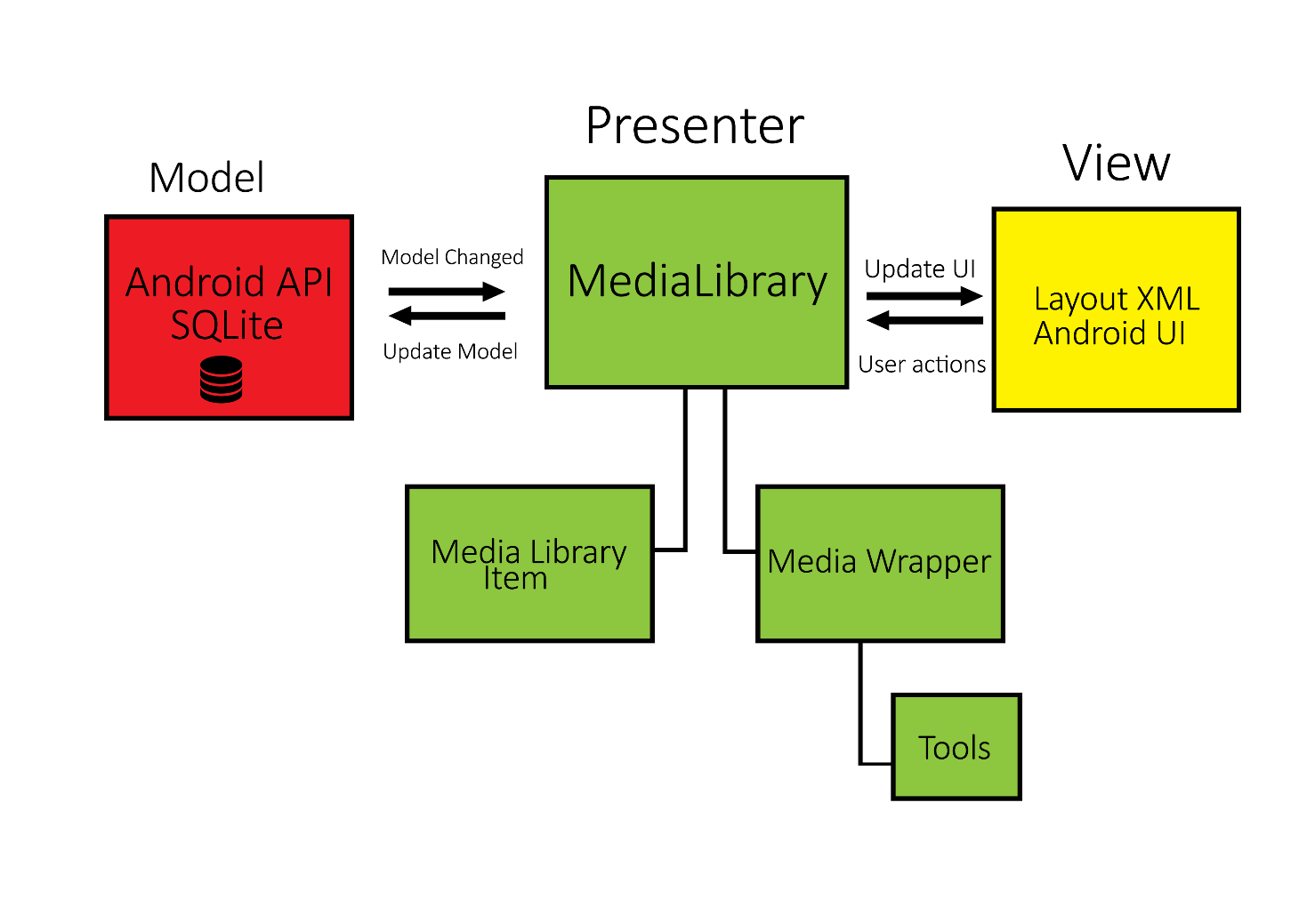

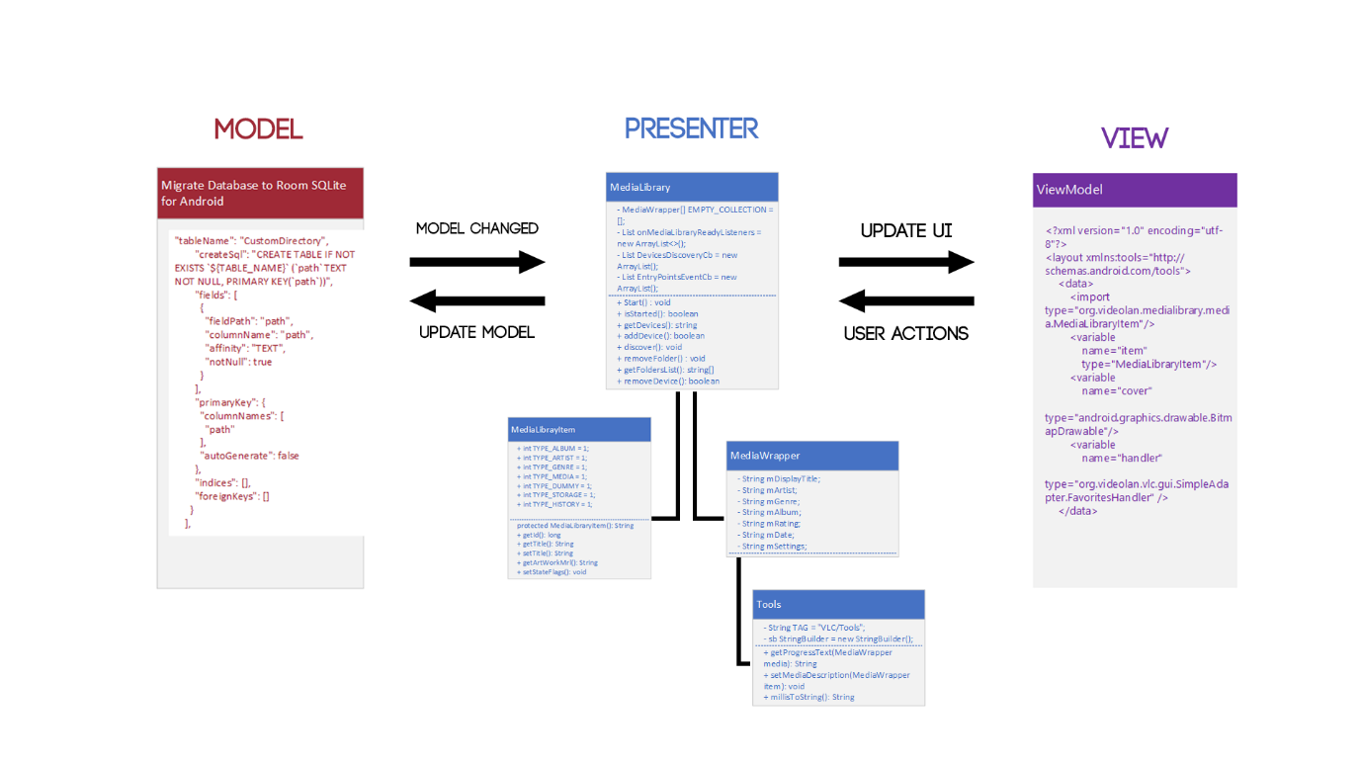

**7. Study Evaluate and analyse what software quality attributes were mostly considered in the software, and the rationale explaining the reason(s).**

# Testability

VLC android is easily testable as its accessible from GITHUB, the software has an inbuilt bug tracker that stores and recorders errors. This particular software has had over 100 million downloads on the google play store with 1 million reviews, all on different android devices old and new.

[https://code.videolan.org/videolan/vlc-android/issues](https://code.videolan.org/videolan/vlc-android/issues%5C)

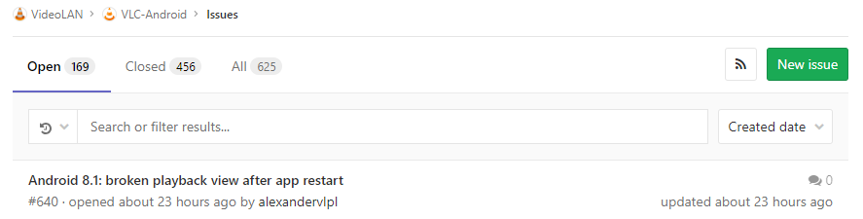

<https://forum.videolan.org/> https://lh3.googleusercontent.com/E1p5d58Z9dWmgcsCWKUiIVN2EZPq-6yNrbk4CXlvRmDcTC8IXoPbWUgQyx9s4Ss3oOvhw3iQti3Hqze65Gfljz4eiXyyspn-aROnAwNuvYxGuu6ep6avM0gEOs93s5UHp4X_rle1

These are the two forums to report bugs and glitches with the software. Problems are addressed quickly  with a lot of discussions on possibility.

The code is extremely easy to compile and run as everything is provided for, so anyone can test the software. I used Android Studio and imported the file.

The main chunk of the software is very basic to understand, using the MVP method. It was a bit difficult to navigate all the files as they are named “src” and “jni”. But once you know what you're looking for, it was very easy to find and identify the model, view and presenter models and subsequent classes.

VLC android on desktop is C language, in order for it to be multipurpose on different platforms. The code had to be rewritten into Java, C# and Objective C.

# Portability

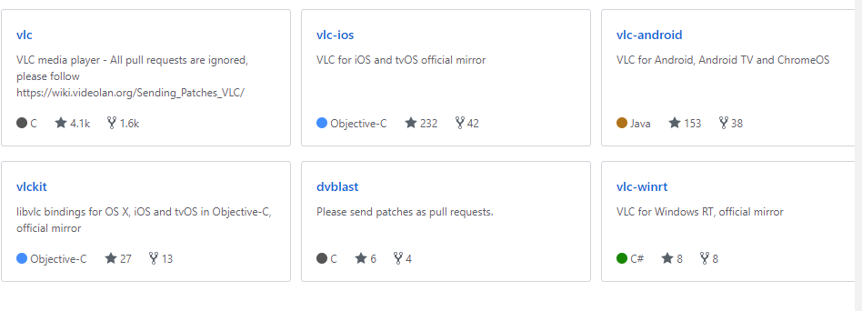

Being open source; everyone with different skill sets in different languages can make contributions to the software. For example: VLC android has 91 contributes with vast experience. The language used was Java and there is program in place to convert Java to C++. So, the software is interchangeable and portable between platforms and operating Systems.

The basis of the software using MVP is relatively simple but with changing GUI’s, API’s and Database platforms it would be easy to create the same pattern but harder to implement it.

The software could not be easily executed on a different OS originally. Until it was rescaled and rebuilt on the other platforms.

# Recoverability

VLC android uses SQLite Database and API. This specific database comes with recovery options that backup the system if there is major failure. It also records and stores errors

<https://www.sqlite.org/backup.html>

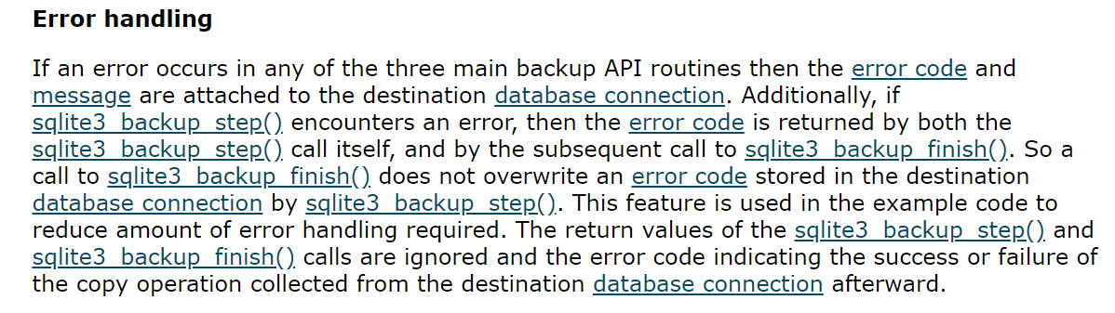

Having VLC android on GITHUB means that the source files are permanently stored online. When changes are suggested they go through a vetting process by other experienced programmers. This means that major failure is very unlikely but if it does happen, the database can roll back the mistakes to be fixed.

The software also has API scaling in place in which if older software running older API can run on new devices.

# References:

Software engineering 9th Edition by Ian Sommerville

<https://www.spaceotechnologies.com/mvp-android-architectural-pattern/>

<https://academy.realm.io/posts/eric-maxwell-mvc-mvp-and-mvvm-on-android/>

<https://mindorks.com/course/android-mvp-introduction>

<https://antonioleiva.com/mvp-android/>

<https://www.techyourchance.com/mvp-mvc-android-1/>

<https://www.youtube.com/watch?v=SGr5GrEndQI>

<https://resources.sei.cmu.edu/library/asset-view.cfm?assetid=513803>

<https://en.wikipedia.org/wiki/List_of_system_quality_attributes>

<https://www.dropbox.com/sh/ijbyig8ls6rctp4/AAC8Tw2acGXkcbmQXBrIqrDxa?dl=0>